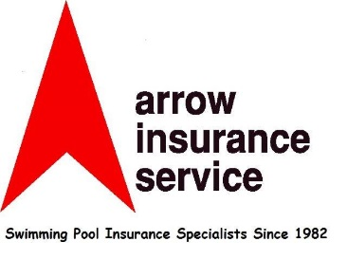

PRE-AUTHORIZED AGREEMENT

Direct Pay (ACH Debits)

Arrow Insurance Service, Inc, is hereby authorized to debit our account, indicated below, for all SPAH dues and insurance premiums. This authorization shall extend to include any late charges, NSF charges, or other amounts due to Arrow Insurance Service, Inc. in connection with SPAH dues and insurance premiums. The funds should be available in the account as of the payment due date. In the event the debit falls on a Saturday, Sunday or holiday, Arrow Insurance Service, Inc. may debit the account on the next succeeding business day of Saturday, Sunday or holiday.

Insured’s Name: (Print) __________________________________________________________

Insured’s Signature: _________________________________________________ Date: ______

Bank Information:

Bank Account Title (or name): _____________________________________________________

Bank Name: ___________________________________________________________________

Bank ABA or Routing Number (9 Digits)*: ____________________________________________

Bank Account Number: __________________________________________________________

Type of Account: Checking ◻ Savings ◻

Bank Account Authorized Signature: _______________________________________________

*Note that the routing number listed on the check/deposit slip is not always the correct ABA number for the ACH transaction. Please confirm with your institution.

A copy of a voided check must be attached

Once completed please return to Arrow Insurance Service, Inc.

Attention: Diane Howard Email: DHoward@arrowinsuranceservice.com

Phone: 800-833-3433 Fax: 805-955-9535

